

Food Port Project

An investigation into the opportunities for industrial effluent to be re-used as agricultural irrigation water

|  |
| --- |
|  |

Water technology group

december 2015

# Food Port project

### An investigation into the opportunities for industrial effluent to be re-used as agricultural irrigation water

### Emma McAteer Researcher, Water Technology Group december 2015 Delta Academy, HZ Univeristy of applied sciences, vlissingen draft version in progress

# ****Table of contents****

Table of contents 2

1. Introduction 3

2. Initial Investigation 3

3. Theoretical Investigation 5

4. Discussion 5

5. Conclusions and Recommendations 12

6. References 13

7. Appendices 14

# Introduction

This investigation and summary report is the second of two investigations triggered by a project proposal by the Centre of Expertise, Delta Technology. The project proposal is entitled: “Re-use and valorization of wastewater within Food Port Beveland-Walcheren.” The project proposes a feasibility study regarding wastewater use from different businesses in the Food Port group, to investigate if this wastewater could be better utilized. The main question of wastewater re-use is whether or not the wastewater produced by the businesses, is suitable for agricultural irrigation. A sub-question from this is: if the water is suitable, is it logistically practical to discharge it to the existing agricultural irrigation network? In order for these questions to be answered, due thought and consideration should be given to the matters of existing wastewater quality, treatment options, logistical restrictions and economic impact.

The matter of existing wastewater quality was handled in the first investigation by Cristian Alvarez Luckow. The details of Cristian’s investigation will be discussed further in chapter 2.

The final report that Cristian produced acted as the starting point for this investigation. This investigation was more theoretical, determining the best treatment options required to treat the water to agricultural irrigation standards and then drawing conclusions and making recommendations based on logistical, practicality and cost considerations.

# Initial Investigation

In his investigation, Cristian Alvarez Luckow worked closely with four companies in Zeeland, in the Food Port group. Those companies were Kloosterboer B.V. based in Nieuwport, CSM Bakery Supplies Europe based in Goes, Coroos Conserven B.V. in Kapelle and Lamb Weston Meijer in Kruiningen. More information about what these individual companies do can be found in Cristian’s report.

In order to try and answer the main research question about whether the wastewater from each of these companies could be used for agricultural irrigation, Cristian had a to answer some subsidiary questions. These subsidiary questions included:

* What type of waste streams do each of the companies produce?
* What is the water quality of each of these waste streams?
* What processes do the companies use and do they influence the wastewater quality?
* What is the required water quality for discharge to the agricultural irrigation network?
* Does the wastewater produced per company meet with the agricultural requirements?
* If not, what further treatment options are available to help reach this water quality?

Cristian’s report gives insight into the processes in place at each company, how much water the companies need for these processes, the concentrations of wastewater the processes produce and the methods each company employs to clean and discharge their wastewater.

The data that Cristian compiled for his report can be found in appendices 1-3. This includes the volumes of water used by each company, the concentrations of specified contaminants in the wastewater and the typical requirements for water discharged to the agricultural irrigation supply.

The information that Cristian compiled which was most useful for this second phase of the investigation, as shown below in Table 1.

**Table 1:** Final water quality comparison between the wastewater streams in the companies and the requirements of agricultural irrigation supply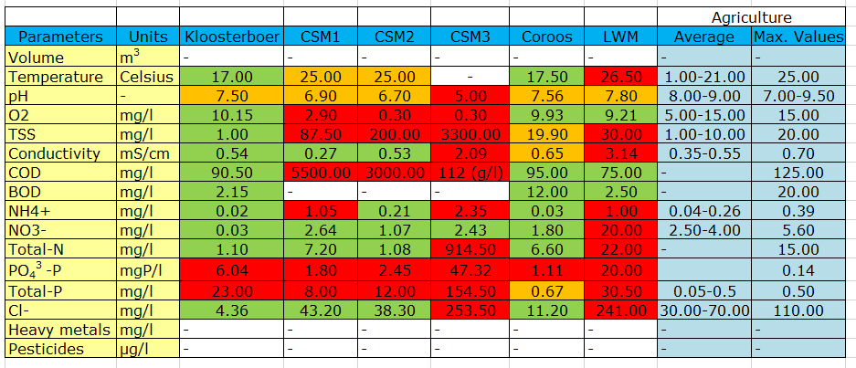

Table 1 is particularly helpful because it shows at a glance what contaminants the next phase of the investigation should focus on. The table is colour coded for ease of use. Any values in a green field are fit to be discharged to agricultural supply without further treatment, any values in an orange field are acceptable for agricultural supply but are bordering on exceeding the set upper and lower limits and finally any value in a red field has exceeded the set limits and cannot be discharged to agricultural supply without further treatment.

Initial observations clearly show that Phosphate is the contaminant that proves most difficult to remove via existing treatment methods. Other contaminants seem to pose problems for some companies but not for others. Overall, it can be said from looking at Table 1 that none of the companies produce a wastewater that can be directly discharged to the agricultural irrigation supply without further treatment.

In Chapter 3, the purpose of the second of the two investigations is explained and how this picked up from where Cristian’s investigation finished.

# Theoretical Investigation

This investigation is the second of two, taking a more theoretical approach to answering the original question; what steps need to be taken for the wastewater from each company to be re-used as agricultural irrigation?

The start point for this investigation is one of the conclusions from the initial investigation by Cristian Alvarez Luckow and represented in Table 1. Based on this table, the contaminants per company that require further treatment can be easily identified and specific treatment options investigated.

From this point onwards, each of the companies will be investigated individually. For the purpose of this investigation into re-use for agricultural irrigation specifically, it was concluded that waste stream CSM 3 should be excluded. Based on the contaminant concentrations in waste stream CSM 3, it can be said that better re-use opportunities than agricultural irrigation exist. In terms of treatment options, an anaerobic digester could be recommended. However, as this waste stream is small in volume, an individual anaerobic digester is not feasible. The most feasible next step for anaerobic digestion would be to investigate if the waste stream from CSM 3 could be added to the waste stream feeding an existing anaerobic digester in the local area.

# Discussion

4.1 Water Treatment

From Table 1, the conclusion could be drawn that none of the waste streams are fit to be discharged directly to agricultural supply. All waste streams require further treatment directed at particular contaminants, if they are to reach the required water quality.

Table 1 shows that all waste streams have difficulty reaching the required pH level for agricultural supply. The maximum limits on pH set for agricultural supply are between 7 and 9.5, with the most common values lying between 8 and 9. All pH levels in the five different waste streams are either outside or barely within the accepted limits. The approach of dosing the waste streams so that the pH levels fall within the accepted limits was considered. It was concluded that when putting the small volume of these waste streams and the larger volume of the agricultural irrigation supply network in perspective, the pH levels in these waste streams would not have a significant impact on the overall water quality of the irrigation network.

The same reasoning was used when examining the temperatures. The maximum accepted temperature for agricultural supply is 25°C, however Lamb Weston Meijer has an average temperature of 26.5°C. As before, the impact that this would have on the overall supply network was deemed to be negligible.

Therefore, pH and temperature were not included as parameters of interest in the next step of the investigation.

4.1.1 Kloosterboer

The original investigation by Cristian Alvarez Luckow discovered that Kloosterboer has existing treatment methods in place, in the form of an aerobic reactor with an MBR (Membrane Bioreactor) underneath. Table 2 below shows the concentration of Kloosterboer’s waste stream in comparison with the required concentrations for agricultural supply.

**Table 2:** Final water quality comparison between Kloosterboer and the requirements of agricultural irrigation supply

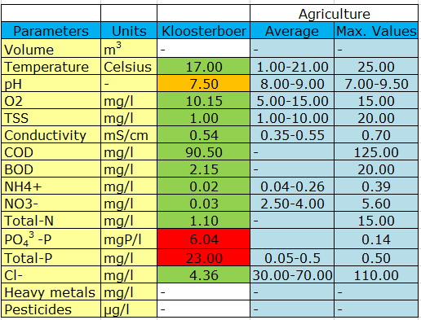

As can be seen in Table 2, the concentration of the Kloosterboer waste stream is close to the requirements for agricultural supply. All contaminants except Phosphate and Total Phosphorous are low enough to be directly discharged. Due to the high levels of Phosphate and Total Phosphorous, the waste stream will have to undergo further treatment before it could be considered for agricultural discharge.

The investigation into further waste water treatment focused solely on technologies that have been proven to be effective in the removal of Phosphate.

One very effective method of removing Phosphate is via precipitation with a chemical. The most common metals used in this precipitation process are Iron, Aluminium and Calcium (Strom, 2006). The use of Struvite (Magnesium Ammonium Phosphate) is also common.

From the precipitation options mentioned above, a further analysis of the most suitable option for the Kloosterboer conditions was carried out.

The use of Struvite Precipitation can be ruled out as the optimum conditions for Struvite to form are not prevalent in the Kloosterboer waste stream. In order for Struvite to form, high concentrations of magnesium, ammonia and phosphate are required (Miles & Ellis). The ammonia level in the waste stream is very low and therefore not optimal for Struvite formation. Struvite formation is also dependent on high conductivity, high pH and low temperature (Miles & Ellis); none of which exist in the Kloosterboer waste stream.

The next form of precipitation to be investigated was calcium. The pH required for optimum precipitation using Calcium Oxide (Lime) is between 8 and 10 (Nassef, 2012). The pH at Kloosterboer is slightly below the optimum. This may be overlooked if Calcium Oxide was the best option in all other areas, however precipitation with Calcium Oxide is known to produce a lot of sludge waste (Strom, 2006) and therefore is not the best choice from a practical viewpoint.

The remaining options for precipitation are Aluminium and Iron. Concentrating on removal rates for Phosphate, Aluminium is the most efficient with an 85% removal rate, over Iron with an 80% removal rate (Nassef, 2012). Not only is the efficiency rate a deciding factor, but the conditions in the waste stream at Kloosterboer are more suited for Aluminium precipitation than Iron. Aluminium precipitation is most optimum in pH conditions between 3.5 and 7.5 and Iron precipitation is most optimum at pH 4 (Nassef, 2012). As the Kloosterboer waste stream has a pH of 7.5, Aluminium precipitation would be the preferred treatment option.

After precipitation with Aluminium, filtration of the water would be recommended before discharge, in order to remove the flocs created by the precipitation. The best filter option in this case would be a rapid gravity sand filter. The advantages of this type of filter include ability to handle higher flows of water (5-20 mh-1 using 0.8 mm sand) and a small footprint on the site (Stuetz, 2009). The sand filter as the final treatment step will ensure that the flocs from precipitation are removed and subsequently TSS (Total Suspended Solids) lowered.

4.1.2 CSM 1 & CSM 2

In the original investigation it was discovered that CSM has no existing treatment methods employed on site. All waste streams from the CSM site are discharged to the public sewer. Table 3 below shows the concentration of the CSM 1 and 2 waste streams, in comparison with the requirements for agricultural supply.

**Table 3:** Final water quality comparison between CSM 1 & CSM 2 and the requirements of agricultural irrigation supply

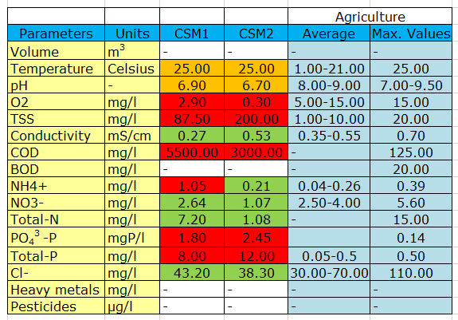

Table 3 shows that CSM 1 and 2 have very high concentrations of some contaminants, leaving it as unsuitable for agricultural supply without further treatment. The largest deviations from the agriculture requirements are the COD (Chemical Oxygen Demand) concentrations in both waste streams.

The focus of the investigation for these waste streams will be on treatment technologies that can remove strong concentrations of COD effectively. As the COD in the water is reduced, the organically bound phosphorous will become free and can be more easily treated, lowering the Total Phosphorous level also.

There are two treatment options which would be best suited for water with such high COD concentrations.

The first treatment option would be a two phase thermophilic anaerobic digester with shortcut biological nutrient removal (SBNR). This would be a good treatment option because it can remove 99% of COD and TSS, 98% Ammonia and 97% Total Phosphorous (Cui, Lee, Kim, 2011). These removal rates would mean that the water in both CSM 1 and CSM 2 waste streams would then be fit for agricultural supply.

See Figure 1 below for a schematic of this treatment set-up.

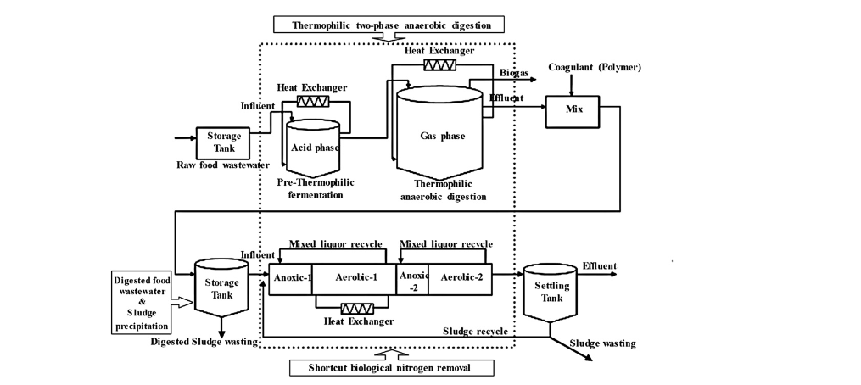

**Figure 1:** Schematic of combined thermophilic two stage anaerobic digestion and SBNR process (Cui, Lee, Kim, 2011)

However, this removal option comes with a lot of dependencies. The removal rates are dependent on; the strength of the influent, the operating temperature and the number of days retention time (Cui, Lee, Kim, 2011). The removal rates given above are the result of an investigation with a hydraulic retention time (HRT) between 18 and 25 days. Depending on the volume of water being produced at CSM, the system needed for the 18-25 days HRT could be very large in size. The removal rates given above were also achieved in thermophilic temperatures of 55°C, maintained by heat exchangers. This need for heat, adds to the operational cost of such a system.

The second treatment option for the CSM site would be the installation of an MBR system with anoxic, anaerobic and aerobic chambers. Such a set up can remove 98% COD, 99% TSS and 95% Ammonia (Monclus et al, 2010). The anaerobic and aerobic chambers ensure that PAOs (Phosphate Accumulating Organisms) can thrive and thus contribute to the reduction of phosphate in the waste stream. A schematic of this type of treatment can be seen in figure 2 below.

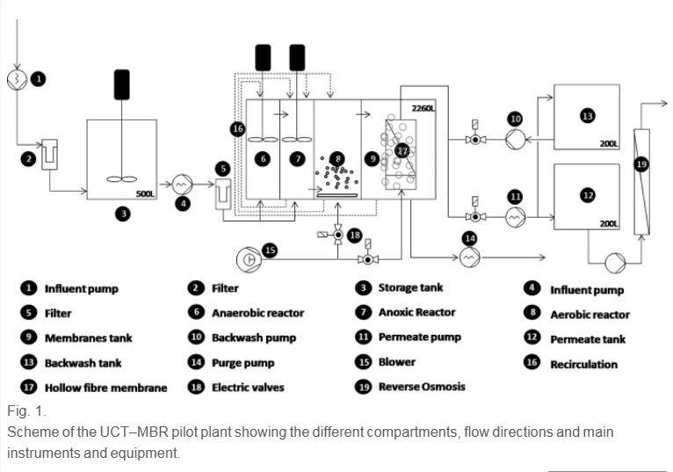

**Figure 2:** Schematic of the MBR pilot plant: compartments, flow direction and equipment. (Monclus et al, 2010)

Both treatment options mentioned above would be a large undertaking to implement on the site. The best option can be recommended after an investigation into cost and logistic considerations in chapter 4.2.

4.1.3 Coroos

In the original investigation, it was discovered that Coroos has an existing waste water treatment plant on their site which consists of primary and secondary treatments. Table 4 below shows the concentration of contaminants in the Coroos waste stream, compared with the requirements for agricultural water supply.

**Table 4:** Final water quality comparison between Coroos and the requirements of agricultural irrigation supply

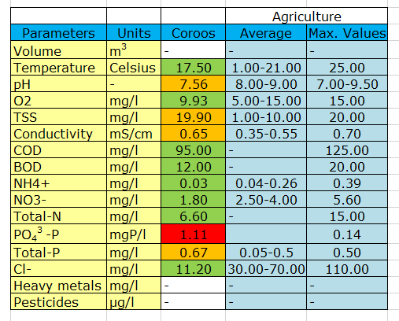

Table 4 shows that the waste stream at Coroos has one contaminant that exceeds the agricultural requirements and some contaminants which are borderline non-acceptable. The contaminant that exceeds the agriculture limit is Phosphate, therefore, this investigation will concentrate on techniques for removing Phosphate from waste water.

One of the most effective methods for removing Phosphate from wastewater is by the utilization of PAOs in biological treatment. PAOs have a removal efficiency of 80-90% in optimum conditions. However a condition needed for PAOs to thrive is the existence of both an aerobic and anaerobic tank (Monclus et al, 2010). At the moment, Coroos only has an aerobic tank in place, meaning that for PAOs to be used, an anaerobic tank would need to be implemented also. This is logistically difficult, requires a large foot print on the site and incurs more costs than the second treatment option. Therefore, PAOs are ruled out as a treatment option for Coroos.

The second option for phosphate removal is precipitation. The most common precipitation techniques were described in 4.1.1 for the site of Kloosterboer. As the concentrations in the waste stream at Coroos are similar to those at Kloosterboer, the recommendation for Coroos would be the same. The best precipitation technique would be precipitation with Aluminium; the pH conditions at Coroos are better suited to Aluminium and it has a higher removal efficiency of 85% (Nassef, 2012).

As with the recommendations for Kloosterboer, a rapid gravity sand filter would also be recommended after precipitation. This sand filter will remove any flocs caused by precipitation from the water and will help lower the TSS (Stuetz, 2009).

4.1.4Lamb Weston Meijer

During the original investigation, Lamb Weston Meijer were noted to have existing treatment methods on site including; an oil skimmer, anaerobic treatment, struvite precipitation and an Anammox system (abbreviation for Anaerobic Ammonium Oxidation). Table 5 below shows the concentration of contaminants in the waste stream at Lamb Weston Meijer, compared to the requirements set by agricultural supply.

**Table 5:** Final water quality comparison between Lamb Weston Meijer and the requirements of agricultural irrigation supply

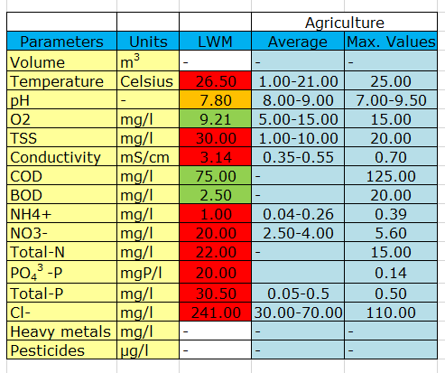

From Table 5 it is clear to see that the majority of the contaminants in the waste stream exceed the limits set for agricultural supply. Further treatment would be required, focusing on a number of contaminants, before the waste stream could be considered fit for agricultural irrigation.

This investigation will focus on how best to combine various treatment techniques in order to remove a selection of contaminants.

Table 5 shows that the COD and BOD levels in the waste stream are at an acceptable level, therefore, biological treatment options will not be considered. This investigation will look at the best chemical and physical treatment options available.

The level of phosphate in the waste stream need to be greatly reduced. This investigation has already covered precipitation for the removal of phosphate, for other sites.

Precipitation with Struvite could be an option as Struvite forms best in conditions with high conductivity and the waste stream at Lamb Weston Meijer has high conductivity (3.14mS/cm). However, Struvite also requires high pH conditions, which do not exist in the Lamb Weston Meijer waste stream.

In this case, precipitation with Aluminium would be a better option. Precipitation with Aluminium can remove 85% of phosphate from wastewater (Nassef, 2012) and as the phosphate level in the waste stream at Lamb Weston Meijer is high, it is recommended to use the technique with the highest removal efficiency.

After precipitation, the water should be filtered to remove the flocs created during precipitation. A rapid gravity sand filter would be recommended here as it takes up a small footprint on the site (Stuetz, 2009). This will mean that the phosphate and TSS levels in the wastewater will have been significantly reduced.

However, one contaminant still exists in strong concentration in the waste stream; Chloride. If this waste stream is to be discharged to the network for agricultural irrigation, the Chloride concentration must be reduced from 241mg/l to preferably 30-70mg/l. The only technique investigated that can remove 99% Chloride from wastewater is Reverse Osmosis. Therefore, a Reverse Osmosis system would be recommended. However, the removal efficiencies for all contaminants by Reverse Osmosis are so high that if the waste stream is treated in this way, it would be clean enough to be re-used in other ways than only agricultural supply.

4.2 Logistic Considerations

Discuss here about whether or not it is logistically possible to reach the agricultural irrigation network, even if the water can be treated down to the required levels

The cost of each treatment option needs to be investigated and incorporated into the decision making process

4.2.1 Kloosterboer

4.2.2 CSM 1 & CSM 2

4.2.3 Coroos

4.2.4 Lamb Weston Meijer

# Conclusions and Recommendations

# References

Cui, F, Lee, S, Kim, M. 2011. Removal of organics and nutrients from food wastewater using combined thermophilic two-phase anaerobic digestion and shortcut biological nitrogen removal. *Department of Civil & Environmental Engineering, Hanyang University, Sa 3-Dong, Ansan, Gyeonggi-Do, Republic of Korea*

Miles, A, Ellis, T.G. Struvite Precipitation Potential for Nutrient Recovery from Anaerobically Treated Wastes. *HDR Engineering, Inc., 8404 Indian Hills Drive, Omaha, NE 68114 and Dept. of Civil and Construction Eng., Iowa State University, Ames, IA 50011-3232.*

Monclus, H. Sipma J. Ferrero, G. Rodriguez-Roda, I. Comas, J. 2010. Biological nutrient removal in an MBR treating municipal wastewater with special focus on biological phosphorous removal. *Laboratory of Chemical and Environmental Engineering (LEQUiA), Institute of the Environment, University of Girona, E17071 Girona, Spain*

Nassef, E. 2012. Removal of Phosphates from Industrial Waste Water by Chemical Precipitation*.  IRACST – Engineering Science and Technology: An International Journal (ESTIJ), ISSN: 2250-3498,Vol.2, No. 3, June 2012*

Strom, P. F. 2006. Technologies to Remove Phosphorous from Wastewater. *Professor of Environmental Science, Rutgers University*

Stuetz, R. 2009. Principles of Water and Wastewater Treatment Processes. *IWA Publishing.*

# Appendices

Appendix 1: water quality parameters

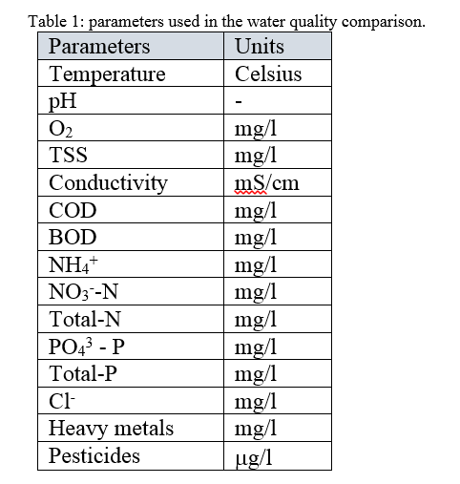

appendix 2: water quality of the waste streams

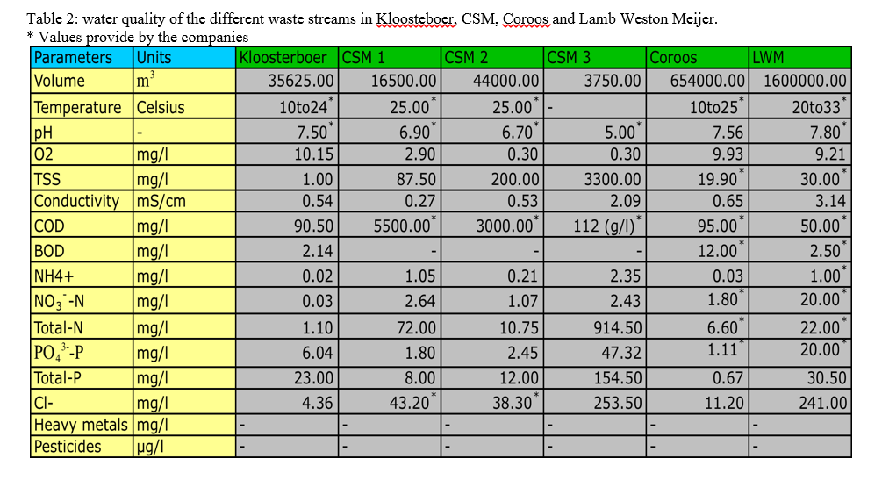

appendix 3: water quality of agricultural supply

